**Lab #9**

**Function Plotting**  
The code for the 3D and 2D plot are as follows:

domain_x=[-2:0.05:2]

domain_y=[-2:0.05:2]

[X,Y]=meshgrid(domain_x,domain_y);

Z=X.*exp(-X.^2-Y.^2)

grid on

surfc(X,Y,Z);

xlabel('x');

ylabel('y');

zlabel('g(x,y)');

title('3D Plot');

figure

grid on

hold on

plot(domain_x,Z(1,:));

plot(domain_x,Z(41,:));

plot(domain_y,Z(:,21));

xlabel('x');

ylabel('y');

title('2D Plot');

legend('g(x,-2)','g(-1,y)','g(x,0)')';

A=max(max(Z))

B=min(min(Z))

The code above produces the following plots:

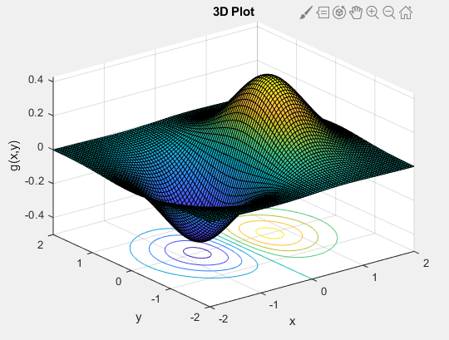

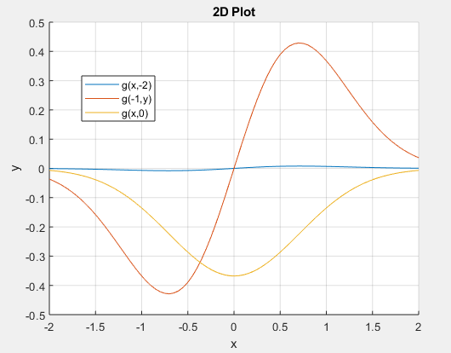

1. Using the code above, the maximum value the 3D plot achieves is 0.4288 and the minimum value the 3D plot achieves is -0.4288. Using the find command in the command window of the Matlab file, I was able to find the location of the maximum value and the minimum value in the matrix produced. Using its location in rows and columns, I was able to find the given x and y coordinates for the maximum and minimum values. Using this method, I was able to figure out the maximum value of 0.4288 is achieved when (x,y) is (0.7000,0) and for the minimum value of -0.4288, I was able to figure out the minimum value of -0.4288 is achieved when (x,y) is (-0.7000,0).
2. The “meshgrid” function in Matlab combines the vectors chosen for the domain and range and converts them into arrays of repeating rows or columns. For the given domain of x, it repeats the same row the same number of times as coordinates in the range. For the given range of y, it repeats the same column the same of times as coordinates in the domain. This is so that element by element operation is possible to get every possible value using all the domain and range values.
3. The 3D plot makes sense. This is because for the values where x is negative, the total result for g(x,y) will be negative. This is because a negative x in the exponent of e would still result in a positive outcome, but when that outcome is multiplied by the negative x in front of it, then the result would be negative. This is shown in the graph when the graph produces a negative value when x<0. When x is positive, then the result is positive as the computation of e with its exponent would result in a positive number and when the respective number is multiplied by positive x, the result would be positive. Hence, the graph is positive when x>0. The value for y would only affect the magnitude of the number as it is in the exponent and no matter the sign, the computation of e would result in a positive number. The 3D plot also makes sense because it corresponds with the 2D plot showing the path of certain variables when some are constant. For example, for part b)i), the plot shows when y=-2 and the 2D plots corresponds with the path in the 3D plot. This is the same for the other points as well.